The Game Master Admin Tool documentation.
General features:

Logon:
Logon on to the application with your admin credentials:

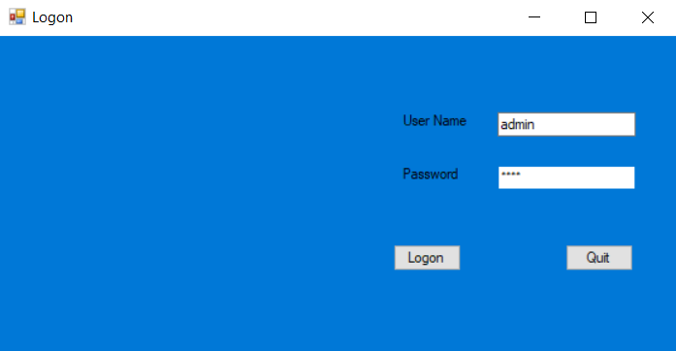

Is your username/password combination is not found you will need to retry:
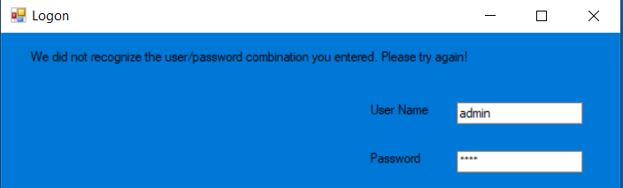

Technical setup documentation:

